Ideation Phase
Define the Problem Statements

Date | 18 February 2026
Team ID | LTVIP2026TMIDS53168
Project Name | TransLingua : AI-Powered Multi-Language Translator
Maximum Marks | 2 Marks

Customer Problem Statement Template:
In today's interconnected world, individuals and professionals often face communication breakdowns due to complex language barriers and inaccurate translation tools. TransLingua solves this by providing a streamlined, AI-powered interface that delivers near-instant, nuanced translations using the Gemini-1.5-flash model. Our solution empowers users to bridge global communication gaps effortlessly, ensuring that language is no longer a barrier to collaboration or exploration.
Customer problem statement
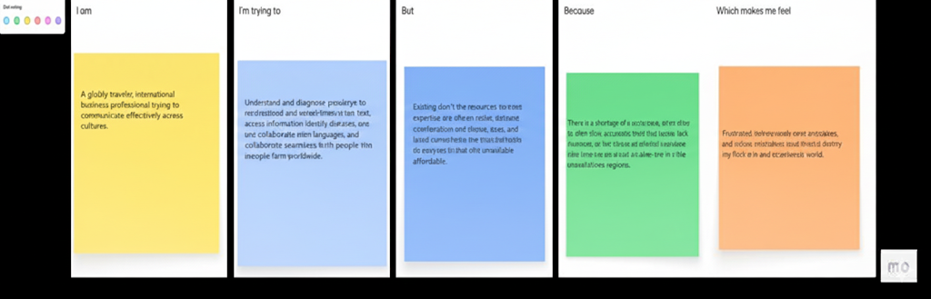

Example:
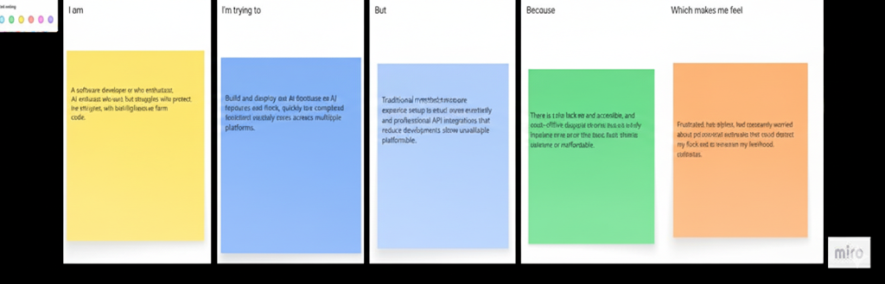

Problem  Statement (PS)  PS-1  Communication Barriers. | I am  (Customer)  A traveler, international student, or business professional navigating a foreign-language environment. | I’m trying to  Understand real-time conversations, read signs, and communicate my needs accurately in a different language. | But  I lack fluency in the local language and find traditional translation apps too slow or inaccurate for natural conversation. | Because  Most tools fail to capture cultural nuance or require complex menus that are difficult to use in high-pressure, real-world situations | Which makes me feel  Isolated, anxious, and frustrated by the inability to express myself or understand my surroundings
Ps-2  Professional Inefficiency | A global team member or remote freelancer collaborating with international clients and partners. | Bridge the gap in professional meetings and documents to ensure technical details aren't lost in translation. | Language barriers cause delays, misunderstandings, and a lack of confidence during critical project discussions. | Current AI translation solutions often provide literal, "robotic" outputs that miss the professional tone and context required for business. | Unprofessional, stressed about potential errors, and limited in my ability to expand my global career reach.

